Deep Learning Assignment 1

Lushaank K 20170010082

Question 1

Design a Multi-layer Perceptron (MLP) for performing XOR gate operation on binary input, where weight will be learnt using Stochastic Gradient Descent (SGD). Write separate function for SGD.

I used a simple non-deep feed forward network with one hidden layer. I use a sigmoid function for Output calculation from each layer. Then update weights on each epoch to get better results.

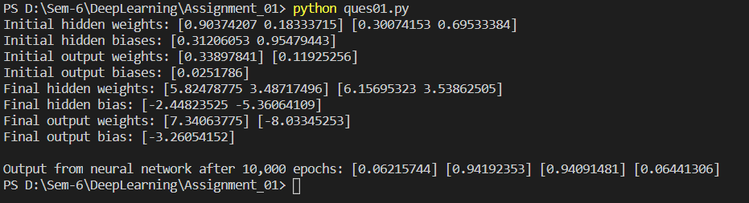

Question 2

Design a Shallow CNN model for the given dataset with the following constraints:

a. Use maximum 3 convolution layers

b. Use maximum 1 fully-connected layer

While running it you would get an image of how a digit(hand-written) can be changed to image that could be read by a machine. Then, using the data from “mnist” of hand written data of numbers. Change the batch size for lesser number of epochs but same time would be taken by all. Put the batch size from range 100 to 150 for better results. We pass it through 2d-Convoultion Network, to Relu, then for MaxPooling for on each of the three layers. At last, we check

for predicted and expected numbers.

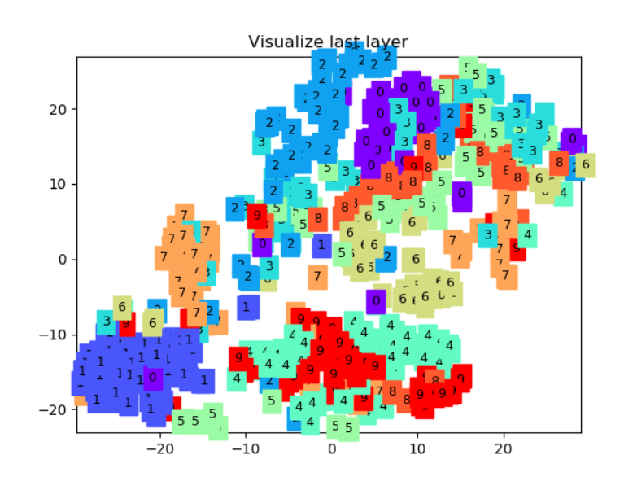

Picture denotes data after first epoch

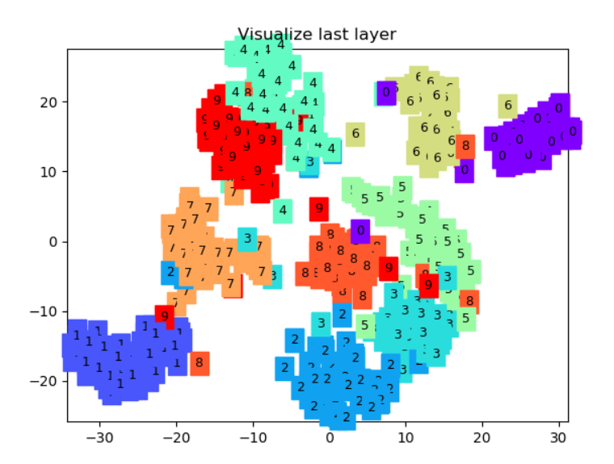

Picture denotes data on last epoch

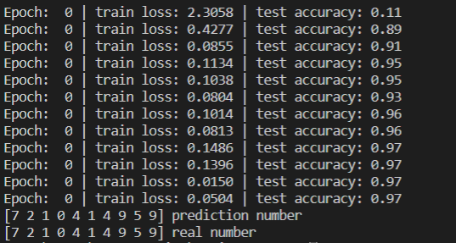

This tells us the changes in training loss and in test accuracies, done on batch size 100, so 12 epochs. Then, Finally checking on real numbers to correctly match and predict the numbers

Question 3

Design a LSTM model of sentiment analysis for the given dataset. Maximum 3 LSTM layers can be used.

A sentence is first stripped of its punctuations then passed on. Data in the system then passed on to be divided into training and test data with three layers of LSTM. Then, the sentence is passed along the LSTM to give the final output as Sentiment. Here, Sentiment can only be Positive or Negative, but not a Neutral case as it is not trained.

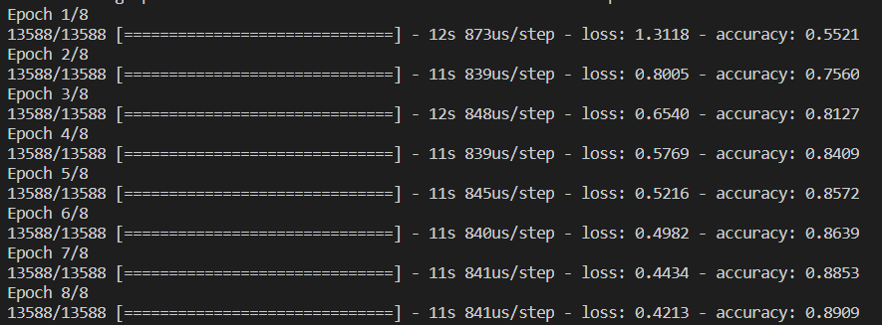

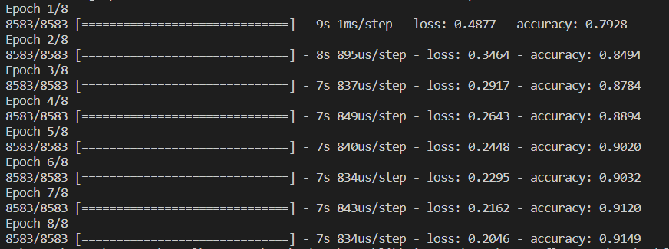

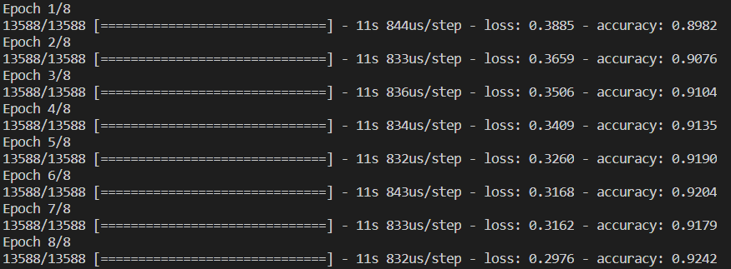

Training of Each Layer for 8 Epochs

Sample Question 1:

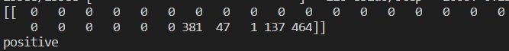

Sample Question 2:

